Step 1: (‎11/‎18/‎2020 4:35:12 PM) User left click on "Type here to search (button)"
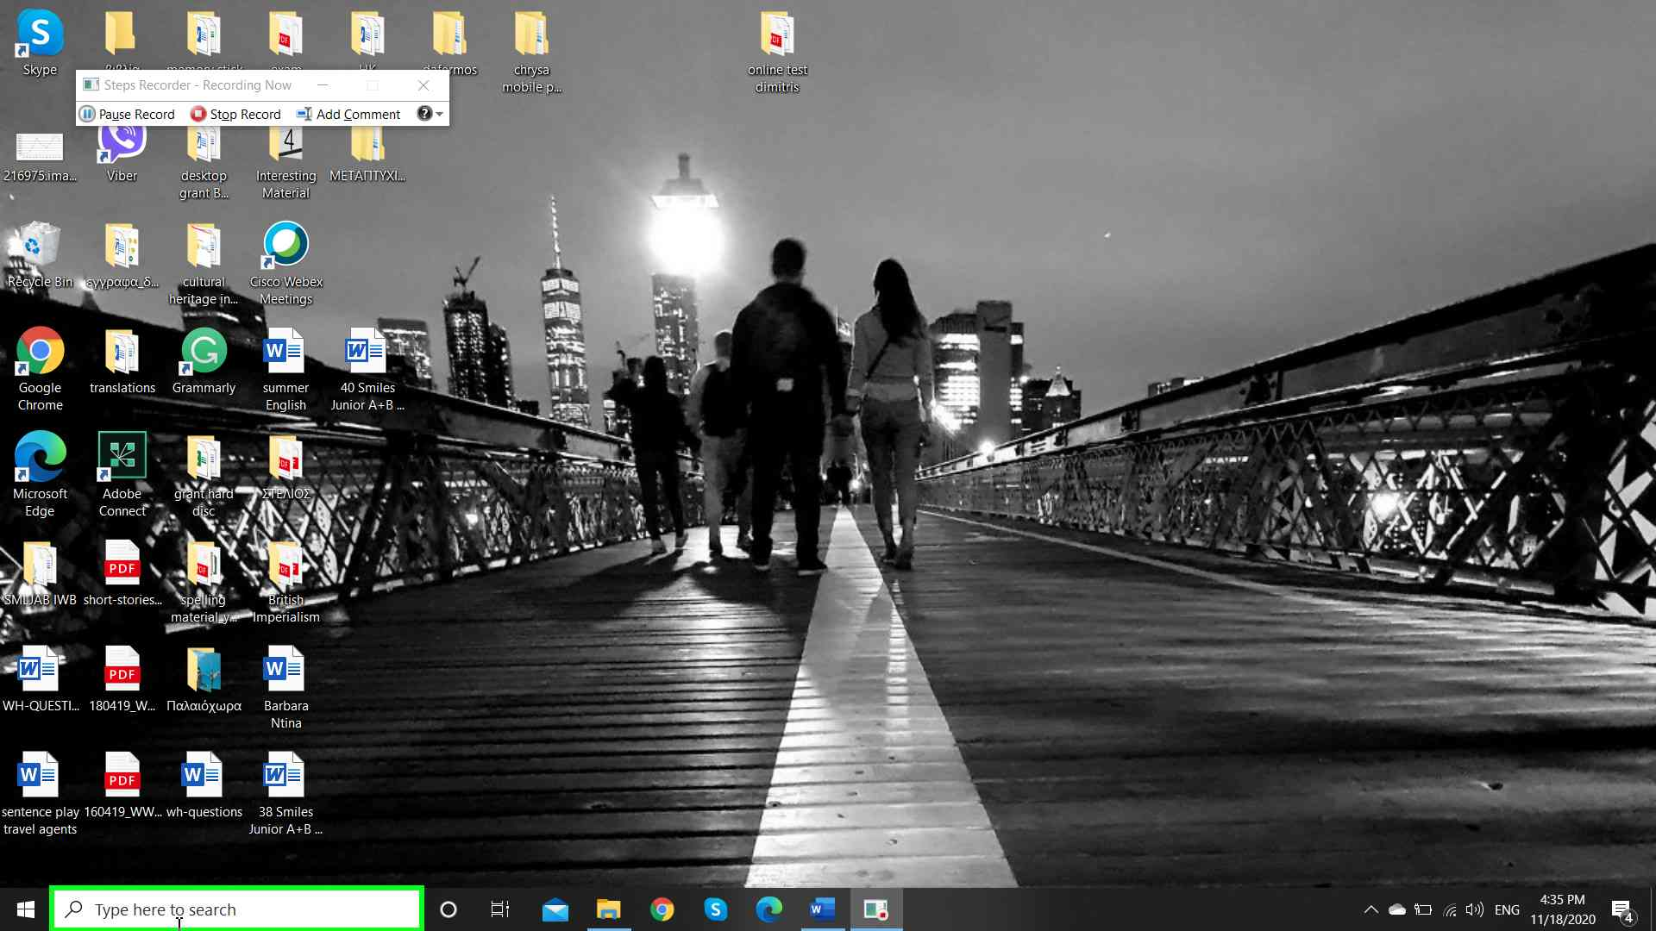Step 1 screenshot.

Previous Next
Step 2: (‎11/‎18/‎2020 4:35:13 PM) User keyboard input on "Cortana (window)" in "Cor" [...]
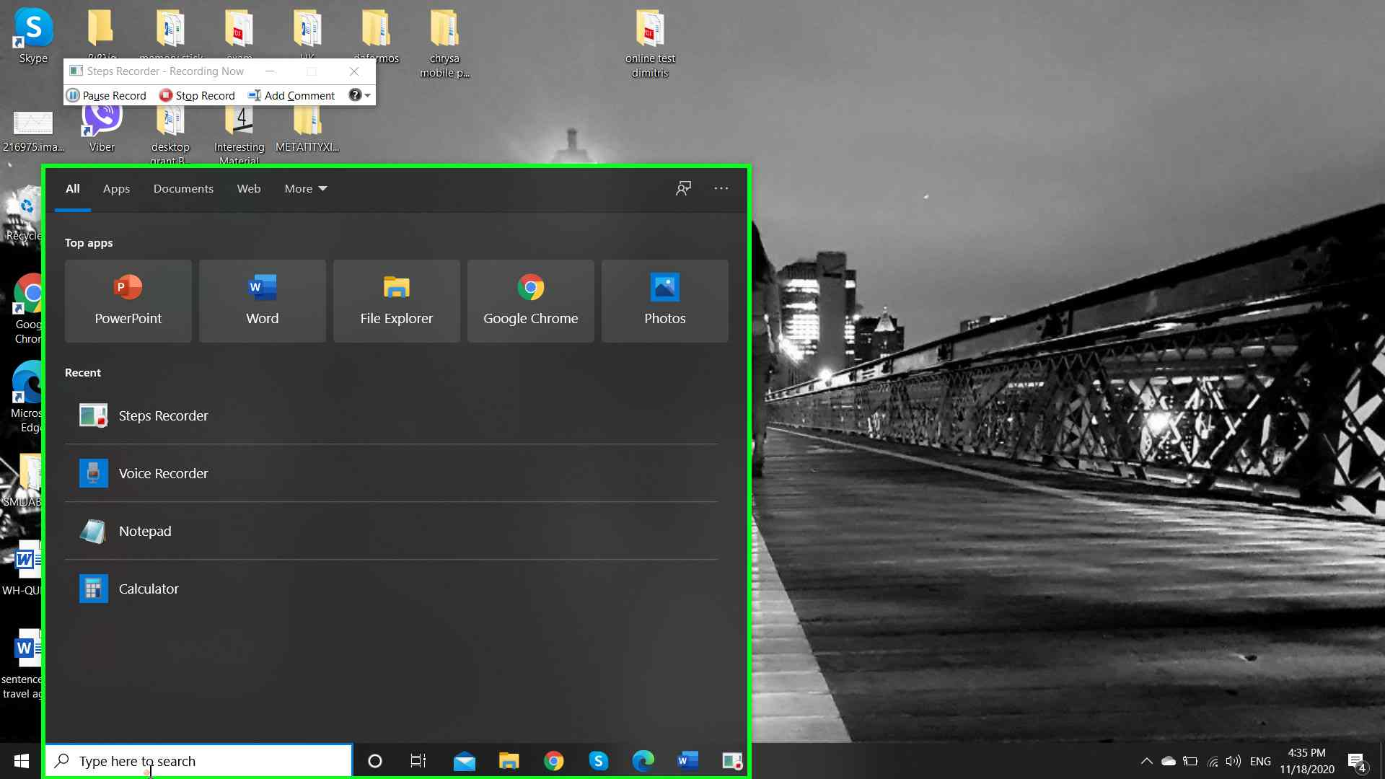Step 2 screenshot.

Previous Next
Step 3: (‎11/‎18/‎2020 4:35:16 PM) User left click on "Voice Recorder, App, Press right to switch preview (list item)" in "Cor"
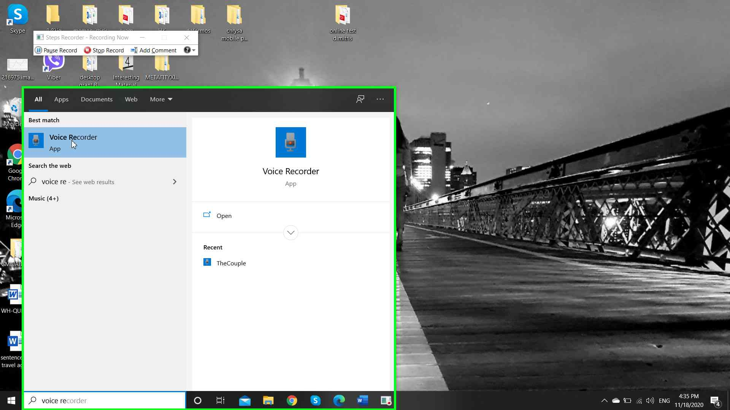Step 3 screenshot.

Previous Next

Step 4: (‎11/‎18/‎2020 4:35:19 PM) User left click on "Start recording (button)" in "Voi"
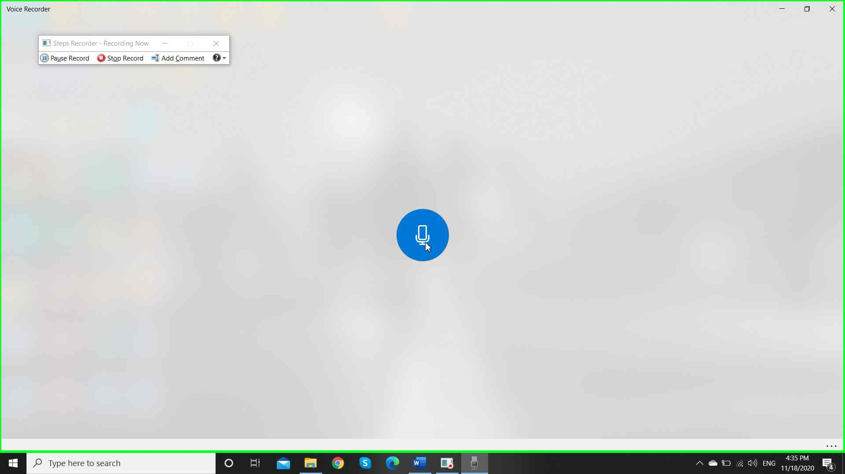Step 4 screenshot.

Previous Next
Step 5: (‎11/‎18/‎2020 4:35:23 PM) User left click on "Stop recording (button)" in "Voi"
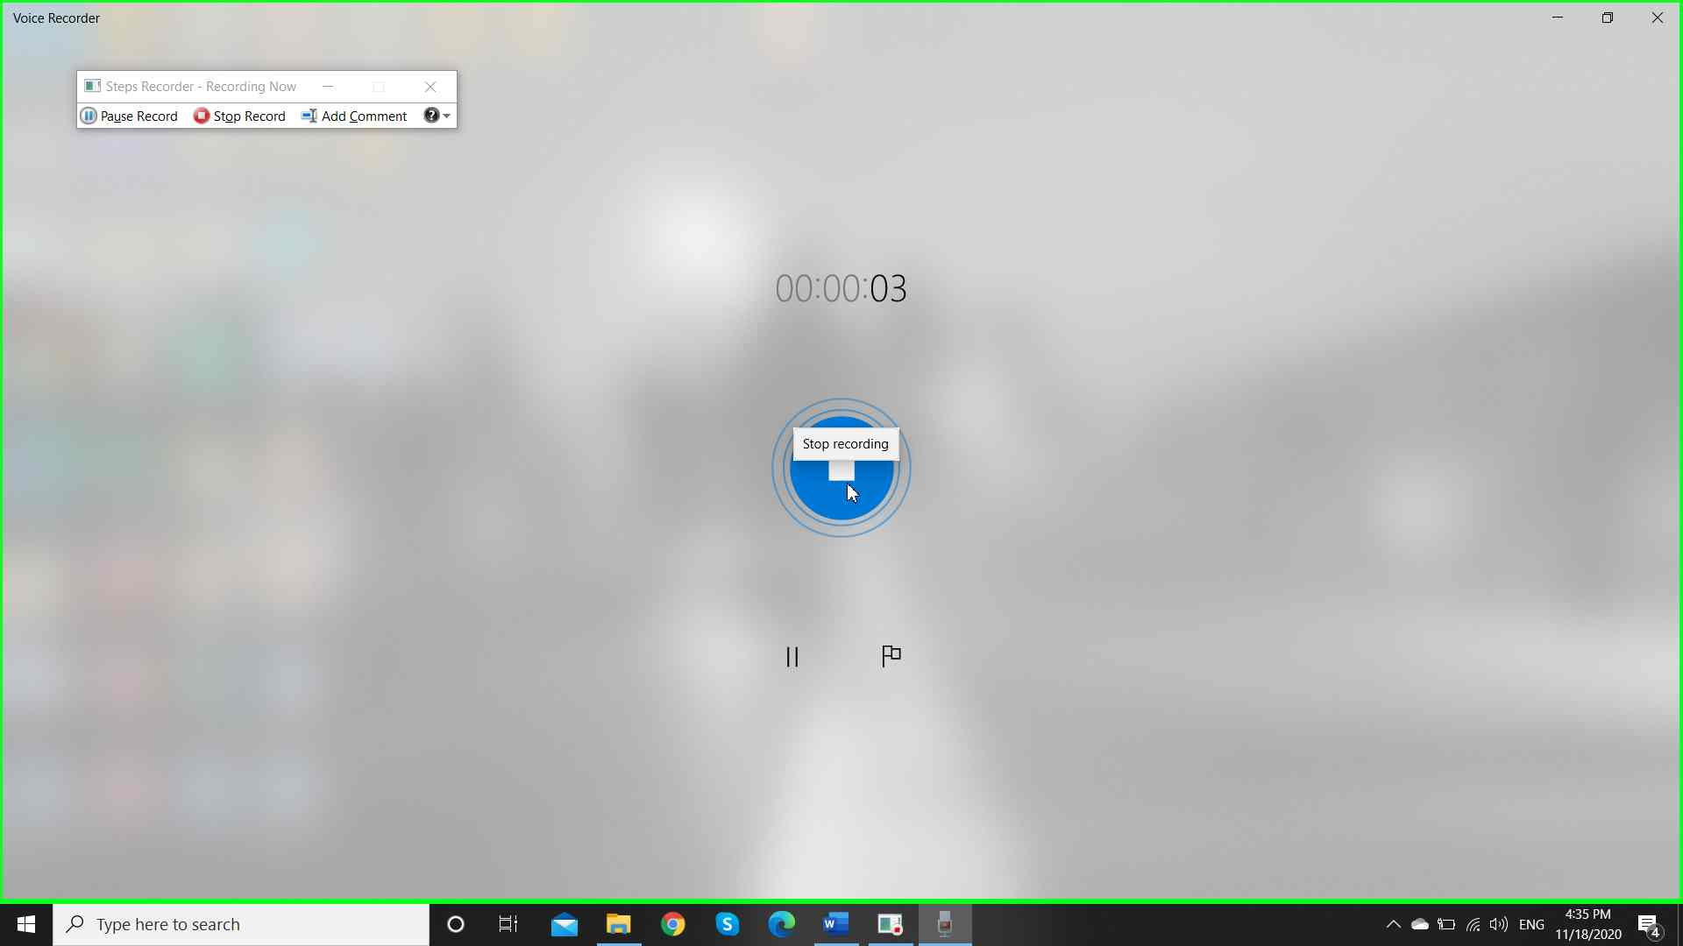

Step 5 screenshot.

Previous Next
Step 6: (‎11/‎18/‎2020 4:35:25 PM) User right click on "Recording, ‎11‎/‎18‎/‎2020 ‎4‎:‎35‎ ‎PM, duration 4 seconds (group)" in "Voi"
